1. **Set Up Azure Resources**
   * Screenshot of the Azure portal displaying the creation of the resource group for the PetStoreApp.

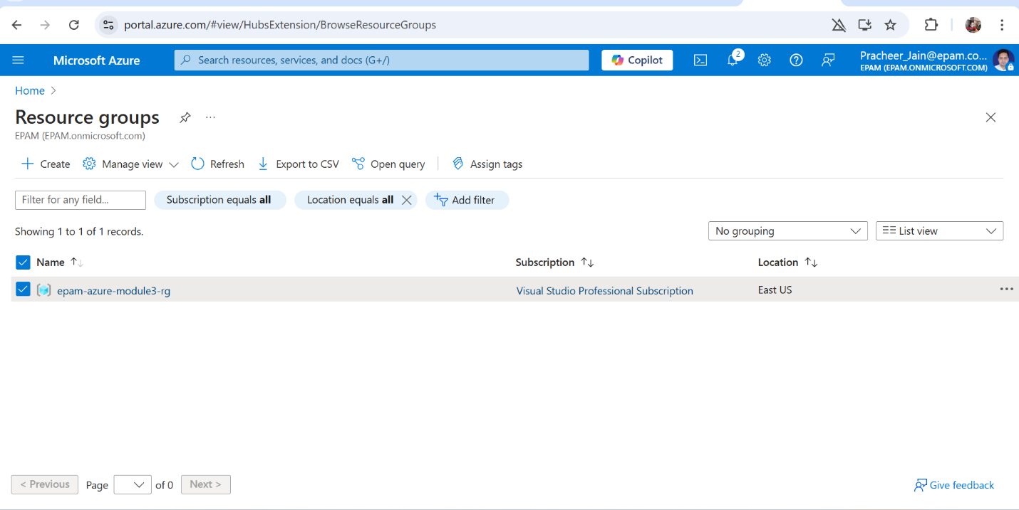

* + Screenshot of the successful creation of the Azure Container Registry (ACR).

* + Screenshots documenting the Docker image build and push process to the ACR.

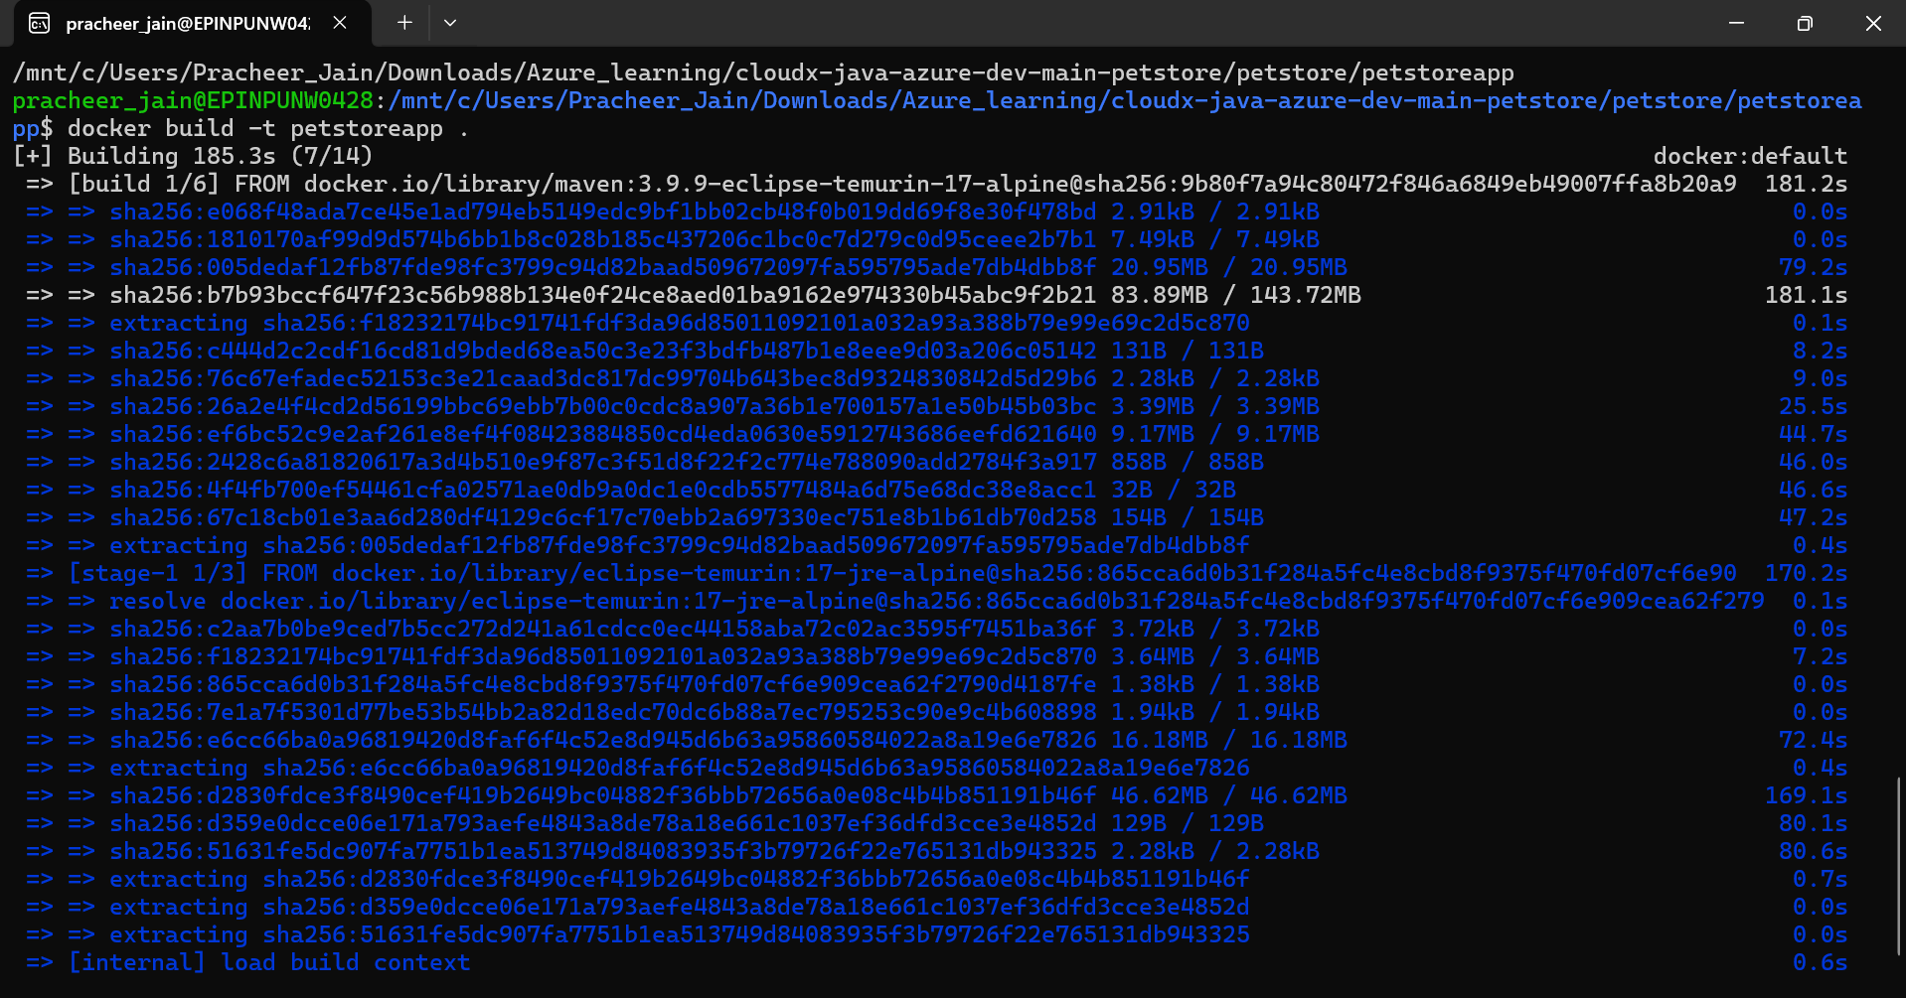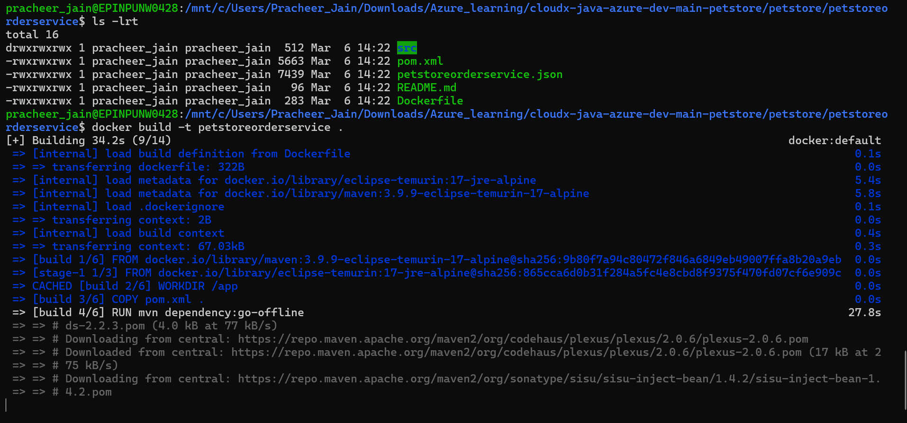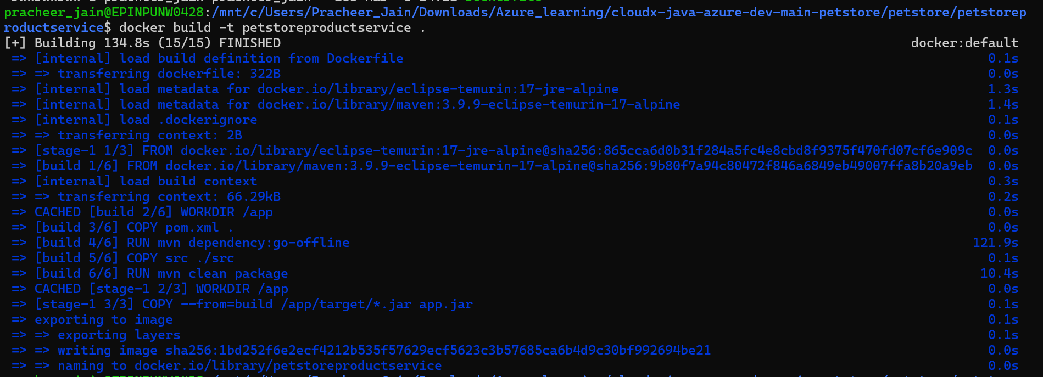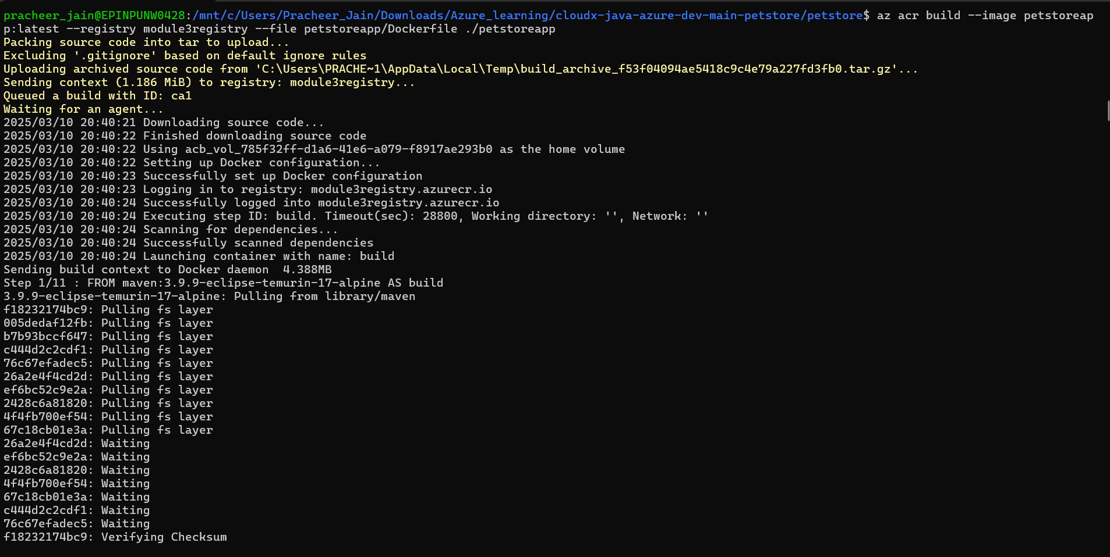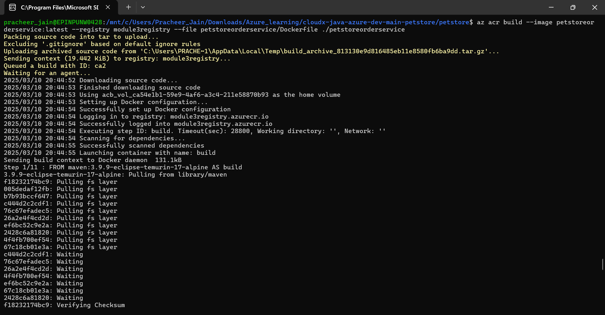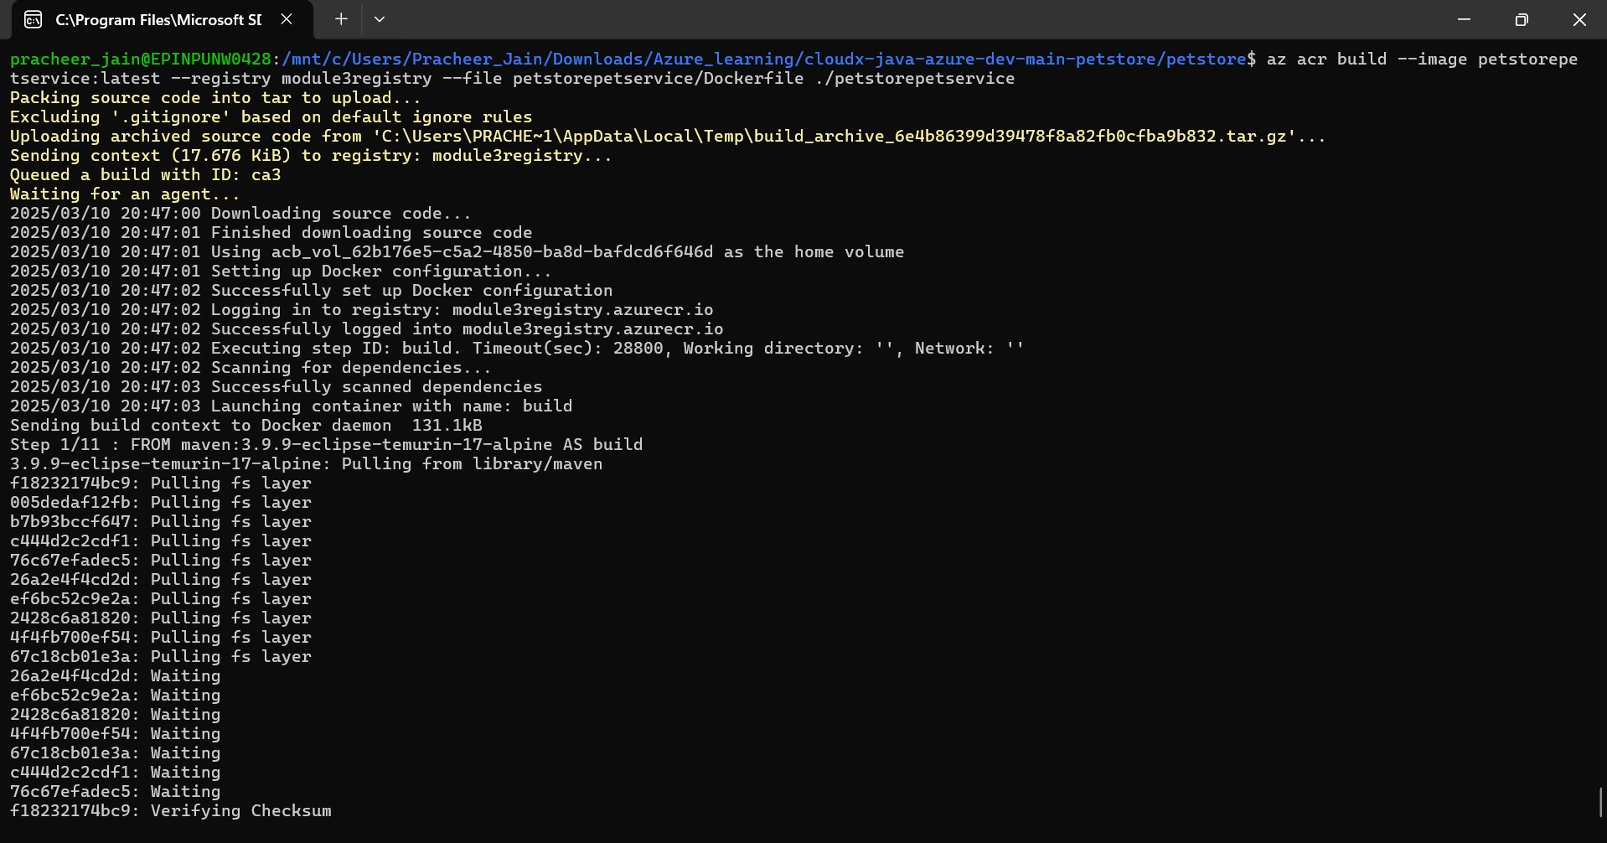

1. Deploy Services to Azure App Services
   * Screenshots of the Azure portal:
     + Creation of App Service Plans for PetStoreApp (Web) and Public API Services.

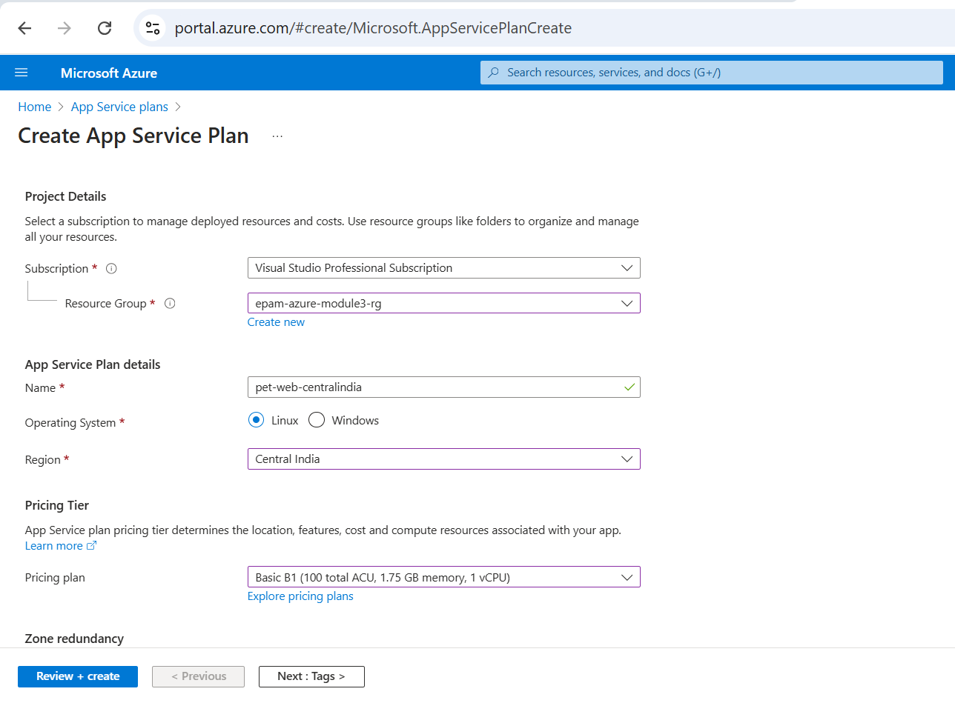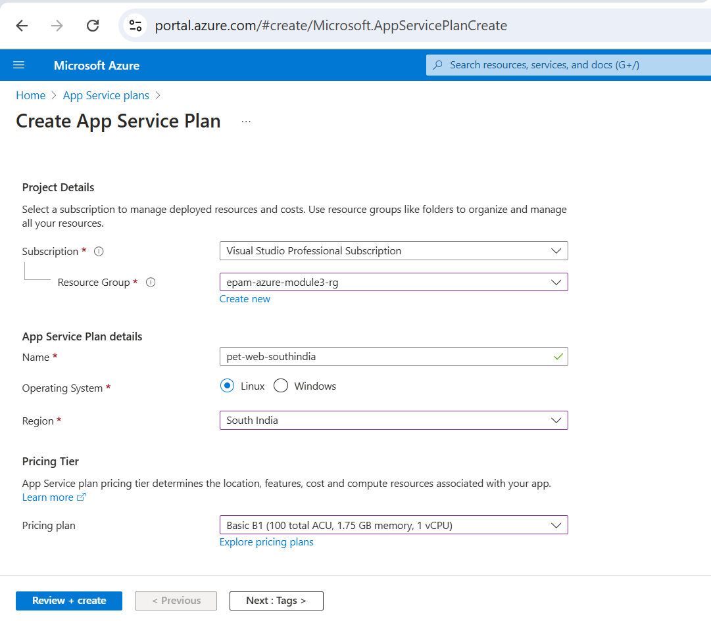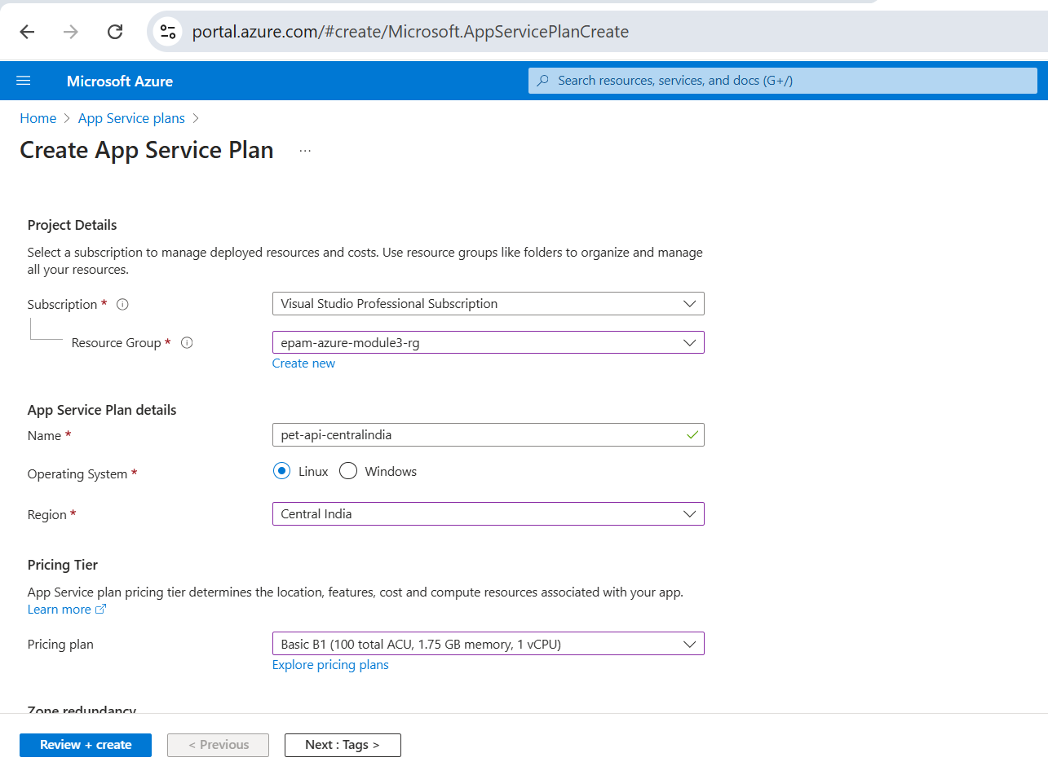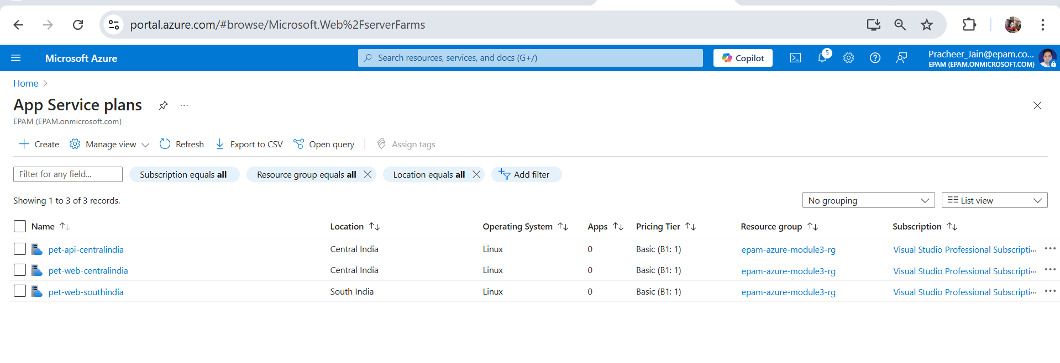

* + - Deployment of PetStoreApp (Web) to two different regions.

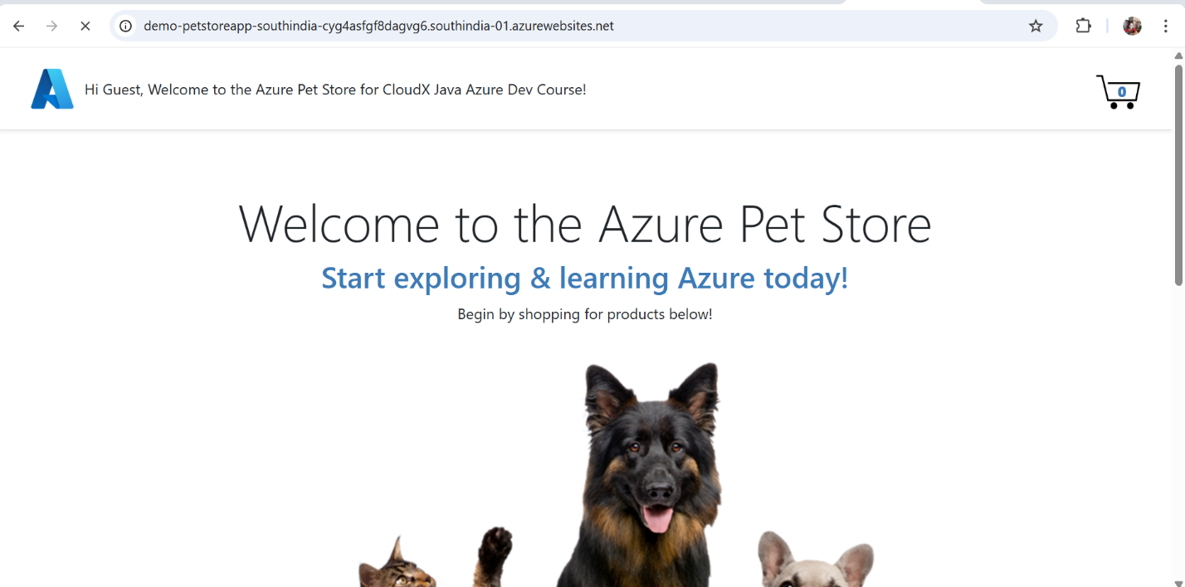

* + - Configuration of environment variables for services communication.

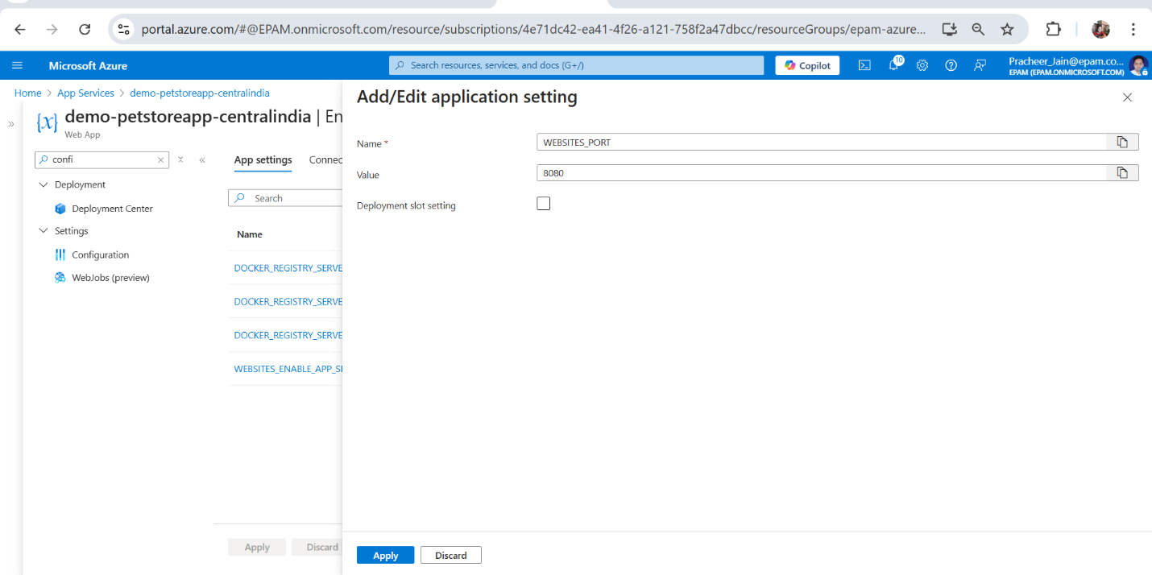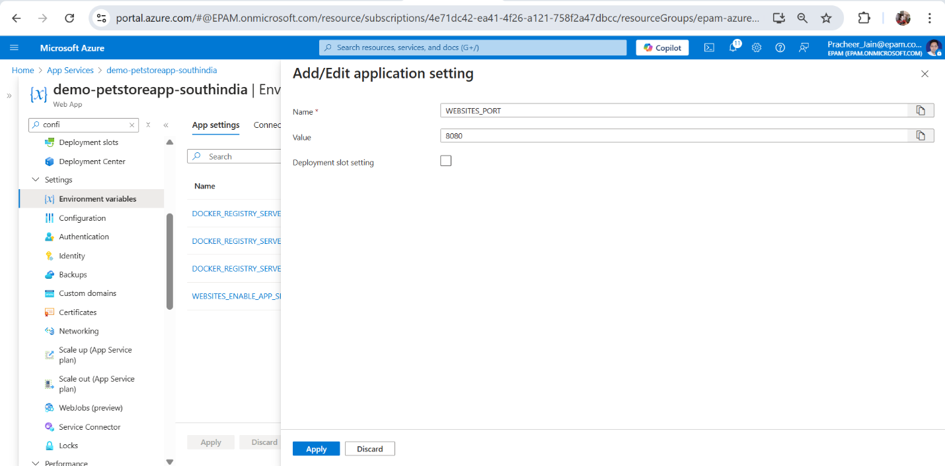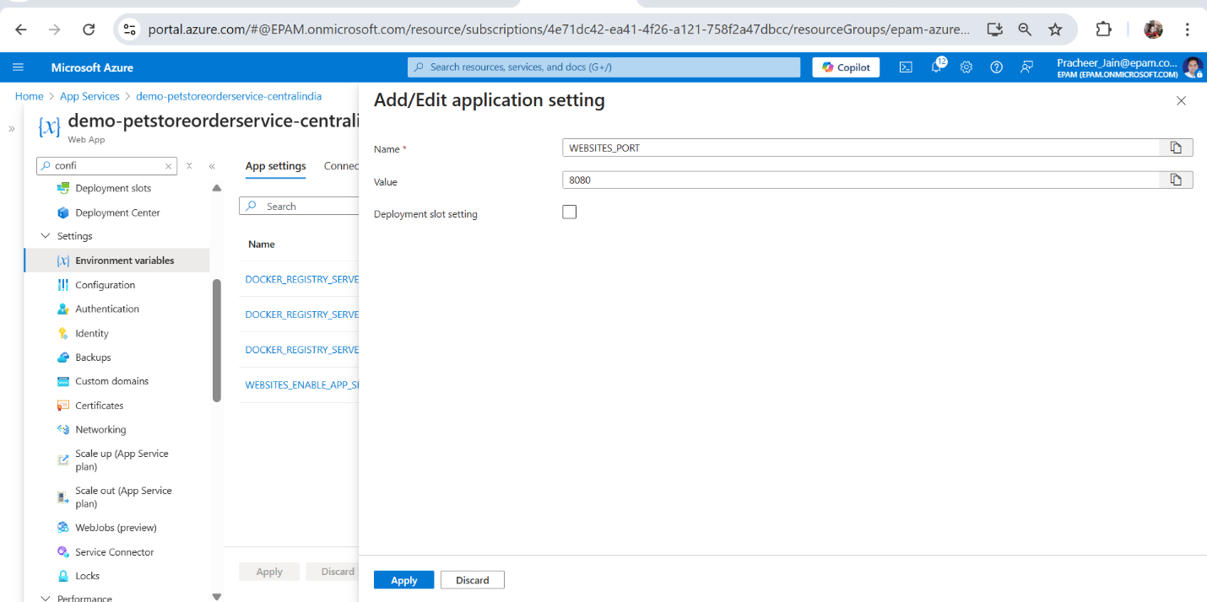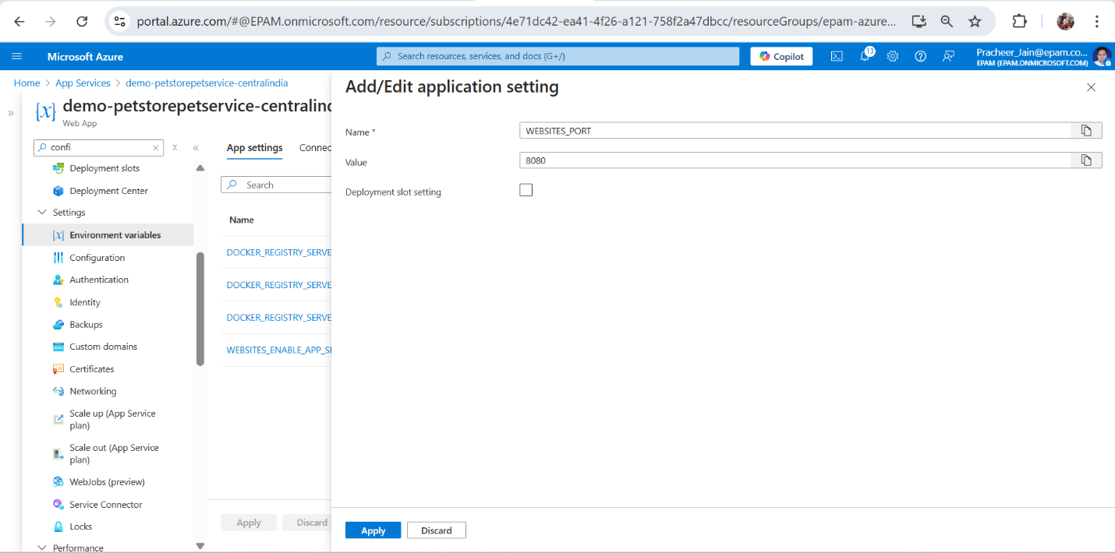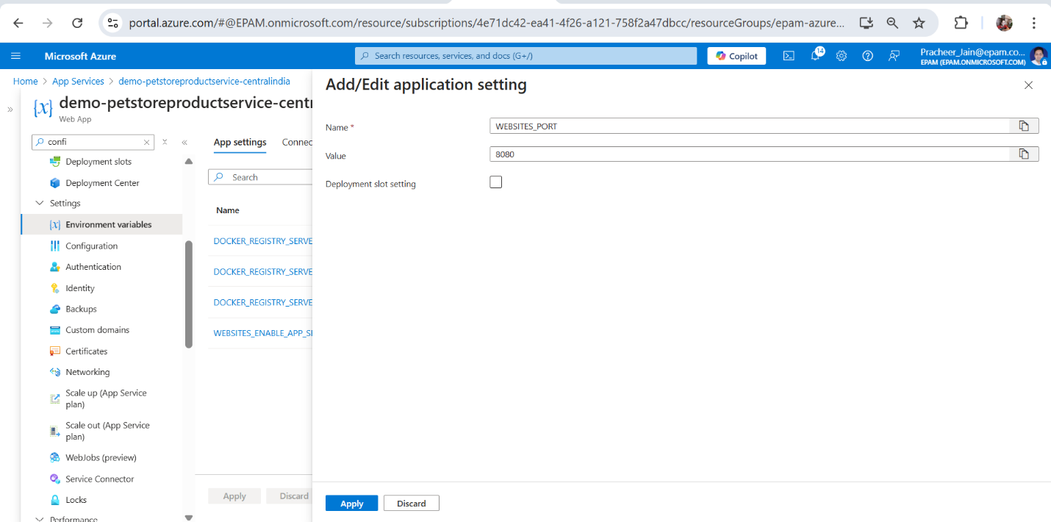

1. Configure Auto-Scaling
   * Screenshots of the Azure portal:
     + Configuration of rules-based autoscaling for public API services.

* + - Setup of custom autoscale settings, including CPU usage thresholds.

* + - Verification of autoscaling settings and rules.

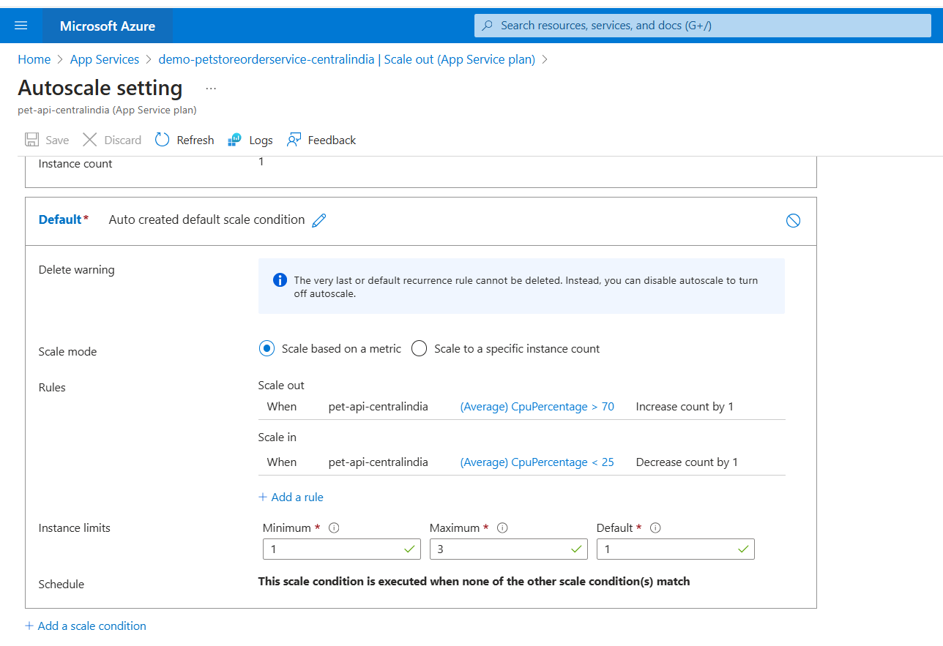

1. Test Autoscaling using k6 Tool
   * Screenshots of Swagger endpoints utilized for testing autoscaling.

* + Screenshots of the k6 tool in use for testing autoscaling.

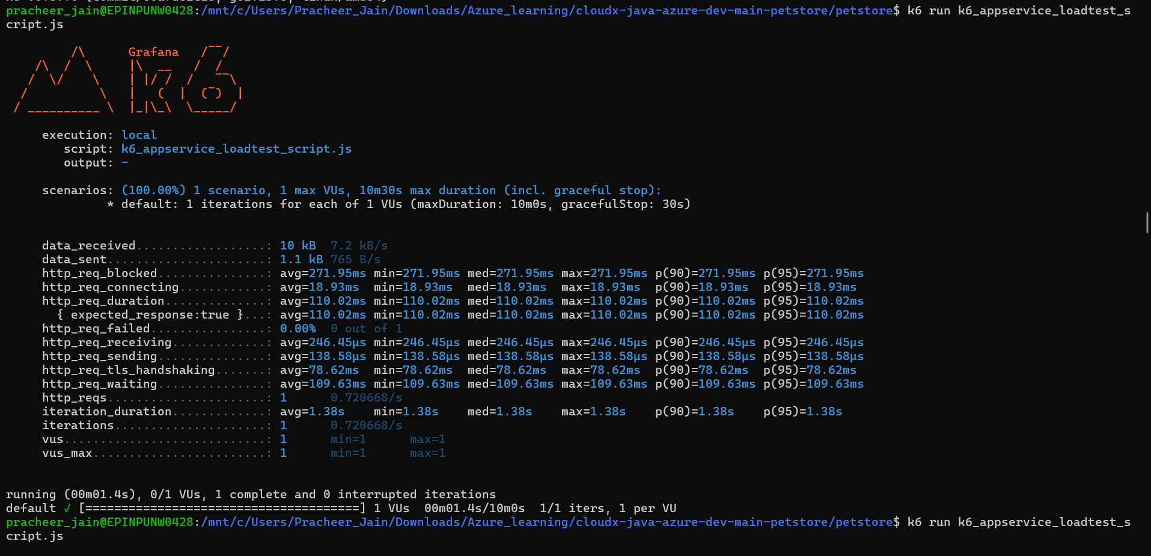

* + Screenshots of the results, particularly showing the scaling behavior under load.

1. Set Up Deployment Slots for PetStoreApp
   * Screenshots of the Azure portal:
     + Creation of a deployment slot for PetStoreApp.

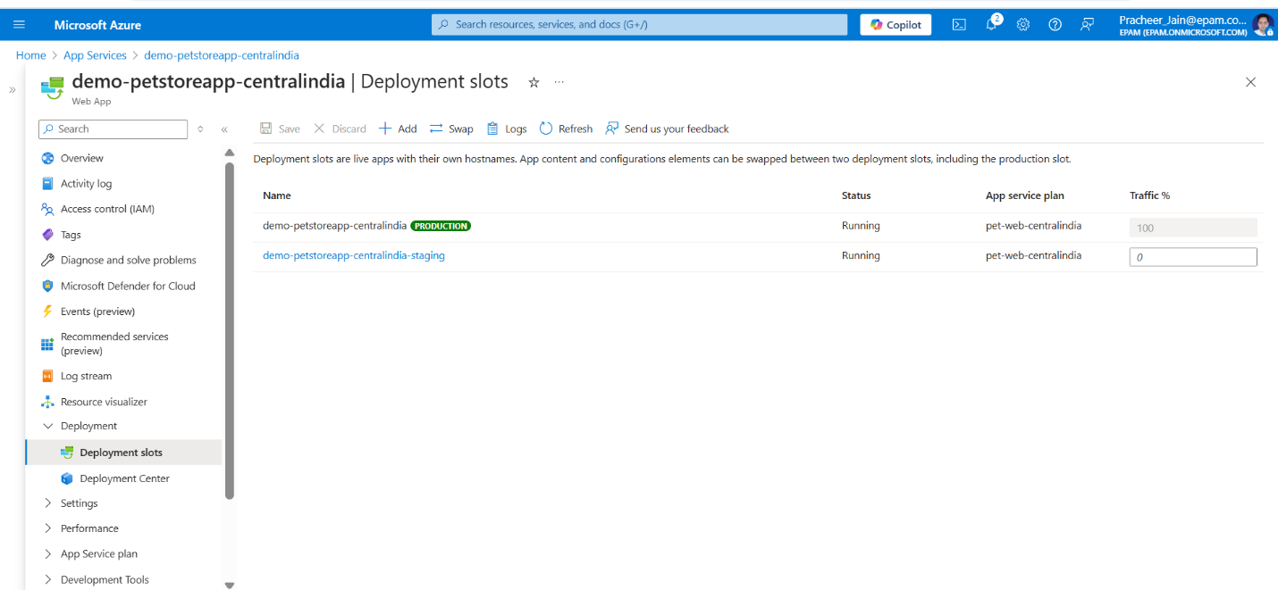

* + - Configuration of slot settings, including continuous deployment.

* + - Successful push of an updated Docker image to the Azure Container Registry.

* + - Testing of the deployment slot and verification of changes.

* + - Screenshot of initiating the slot swap process.

1. Configure Traffic Manager
   * Screenshots of the Azure portal:
     + Creation of a Traffic Manager profile.

* + - Addition of endpoints representing different PetStoreApp instances.

* + - Configuration of health checks for endpoint availability.

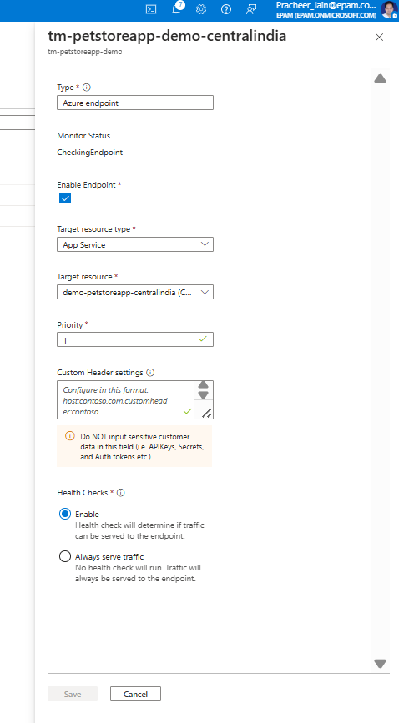

* + - Use of Traffic Manager URL to access the application.

* + Screenshots or GIF-file:
    - Testing of the main application features through the Traffic Manager URL.

1. A screenshot showing the list of Azure resources that correspond to the diagram.

